Chapter 3, Problem 87.

For the circuit in Fig. 3.123, find the gain v_{o}/v_{s}.

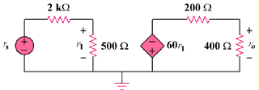

Figure 3.123
For Prob. 3.87.

